Multi-Agent AI for Advanced Hospitality Design

A Project-II Report
Submitted in partial fulfillment of requirement of the
Degree of
BACHELOR OF TECHNOLOGY in COMPUTER SCIENCE & ENGINEERING
BY
Angel Gurjar EN22CS301123
Kirti Choudhary EN22CS301508
Mahi Vishwakarma EN22CS301568
Pavani Kanoongo EN22CS301699
Sahil Shrichand Talreja EN22CS301838
Saiyad Ishan Ali EN22CS301839

Under the Guidance of
Dr. Hemlata Patel



Department of Computer Science & Engineering
Faculty of Engineering
MEDICAPS UNIVERSITY, INDORE- 453331

JAN-JUNE 2026

Multi-Agent AI for Advanced Hospitality Design

A Project-II Report
Submitted in partial fulfillment of requirement of the
Degree of
BACHELOR OF TECHNOLOGY in COMPUTER SCIENCE & ENGINEERING
BY
Angel Gurjar EN22CS301123
Kirti Choudhary EN22CS301508
Mahi Vishwakarma EN22CS301568
Pavani Kanoongo EN22CS301699
Sahil Shrichand Talreja EN22CS301838
Saiyad Ishan Ali EN22CS301839

Under the Guidance of
Dr. Hemlata Patel



Department of Computer Science & Engineering
Faculty of Engineering
MEDICAPS UNIVERSITY, INDORE- 453331

JAN-JUNE 2026
Report Approval

The project work “Multi-Agent AI for Advanced Hospitality Design” is hereby approved as a creditable study of an engineering subject carried out and presented in a manner satisfactory to warrant its acceptance as prerequisite for the Degree for which it has been submitted.
It is to be understood that by this approval the undersigned do not endorse or approved any statement made, opinion expressed, or conclusion drawn there in; but approve the “Project Report” only for the purpose for which it has been submitted.

Internal Examiner
Name:
Designation
Affiliation

External Examiner
Name:
Designation
Affiliation

Declaration

We hereby declare that the project entitled “Multi-Agent AI for Advanced Hospitality Design” submitted in partial fulfillment for the award of the degree of Bachelor of Technology in ‘Computer Science & Engineering’ completed under the supervision of Dr. Hemlata Patel, Asst. Professor, Computer Science & Engineering Department, Faculty of Engineering, Medicaps University Indore is an authentic work.
Further, we declare that the content of this Project work, in full or in parts, have neither been taken from any other source nor have been submitted to any other Institute or University for the award of any degree or diploma.

Signature and name of the student(s) with date
Angel Gurjar

Kirti Choudhary

Mahi Vishwakarma

Pavani Kanoongo

Sahil Shrichand Talreja

Saiyad Ishan Ali

Certificate

I, Dr. Hemlata Patel, Asst. Professor certify that the project entitled Multi-Agent AI for Advanced Hospitality Design” submitted in partial fulfillment for the award of the degree of Bachelor of Technology by Angel Gurjar, Kirti Choudhary, Mahi Vishwakarma , Pavani Kanoongo, Sahil Shrichand Talreja, Saiyad Ishan Ali is the record carried out by them under my guidance and that the work has not formed the basis of award of any other degree elsewhere.

________________________________
Dr. Hemlata Patel
Asst. Professor
Computer Science & Engineering
Medicaps University, Indore
________________________________
Rishabh Tripathi
Project Leader
Datagami Technology Services Private Limited

_____________________
Dr. Kailash Chandra Bandhu
Head of the Department
Computer Science & Engineering
Medicaps University, Indore

Acknowledgements

We would like to express my deepest gratitude to Honorable Chancellor, Shri R C Mittal, who has provided me with every facility to successfully carry out this project, and my profound indebtedness to Prof. (Dr.) D. K. Patnaik, Vice Chancellor, Medicaps University, whose unfailing support and enthusiasm has always boosted up my morale. We also thank Prof. (Dr.) Ratnesh Litoriya, Associate Dean, Faculty of Engineering, Medicaps University, for giving me a chance to work on this project. We would also like to thank my Head of Department Dr. Kailash Chandra Bandhu for his continuous encouragement for the betterment of the project.

We express my heartfelt gratitude to my External Guide, Rishabh Tripathi, Project Leader, Datagami Technology Services Private Limited as well as to my Internal Guide, Dr. Hemlata Patel, Asst. Professor, Computer Science & Engineering, Medicaps University, without whose continuous help and support, this project would ever have reached to the completion.

It is their help and support, due to which we became able to complete the design and technical report.

Without their support this report would not have been possible.

Angel Gurjar
Kirti Choudhary
Mahi Vishwakarma
Pavani Kanoongo
Sahil Shrichand Talreja
Saiyad Ishan Ali

B.Tech. IV Year
Department of Computer Science & Engineering
Faculty of Engineering
Medicaps University, Indore

Abstract

This project focuses on the development and deployment of a specialized AI-driven application titled Multi-Agent AI for Advanced Hospitality Design. It integrates multi-agent systems—utilizing frameworks like LangChain, CrewAI, and Pydantic—to automate complex architectural research and design visualization tasks. The system allows users to input design visions, which are then processed by AI agents to generate detailed architectural concepts and high-fidelity 3D visual representations. To ensure professional-grade reliability and scalability, the project implements a robust DevOps framework. This includes a Continuous Integration (CI) pipeline via GitHub Actions for automated syntax verification and dependency management, alongside Docker containerization to provide a consistent, portable environment for deployment.
Keywords:
Multi-Agent Systems, LangChain, CrewAI, Hospitality Design, DevOps, CI/CD, Docker, Streamlit, Architectural Visualization.

Table of Contents
 |  | Page No.
 | Report Approval | ii
 | Declaration | iii
 | Certificate | iv
 | Acknowledgement | v
 | Abstract | vi
 | Table of Contents | vii
 | Abbreviations | x
Chapter 1 | Introduction (Whichever is applicable)
 | 1.1 Introduction | 1
 | 1.2 Literature Review
 | 1.3 Objectives
 | 1.4 Significance
 | 1.5 Research Design
 | 1.6 Source of Data
 | 1.7 Chapter Scheme
Chapter 2 | (Report on Present Investigation)
 | 2.1 Experimental Set-up
 | 2.2 Procedures Adopted
 | 2.3
Chapter 3 | (Main Chapter)
 | 3.1
Chapter 4 | Main Chapter (Optional)
Chapter 6 | Main Chapter (Optional)
Chapter 6 | Main Chapter (Optional)
Chapter 7 | Results and Discussions
Chapter 8 | Summary and Conclusions
Chapter 9 | Future scope
 | Appendix
 | Bibliography
 | List of Publications (If any)
 | Reprints of publications(If any)
Note | Results and Discussions may not be a separate chapter it may be included in main chapter
Abbreviations
The following abbreviations are used throughout this report to represent technical frameworks, methodologies, and organizations involved in the project:
- AI: Artificial Intelligence
- API: Application Programming Interface
- CD: Continuous Deployment
- CI: Continuous Integration
- CSE: Computer Science and Engineering
- GenAI: Generative Artificial Intelligence
- HF: Hugging Face
- IEEE: Institute of Electrical and Electronics Engineers
- IT: Information Technology
- LLM: Large Language Model
- RAG: Retrieval-Augmented Generation
- UI: User Interface
- YAML: Yet Another Markup Language

Chapter 1: Introduction
1.1 Introduction
The project, Multi-Agent AI for Advanced Hospitality Design, explores the intersection of Agentic AI and architectural planning. It utilizes a multi-agent orchestration layer to transform user design visions into structured architectural concepts and 3D visual representations.
1.2 Literature Review
Current trends in software development show a significant shift toward Agentic Workflows using frameworks like CrewAI and LangChain. Existing research in hospitality design often lacks the integration of automated CI/CD pipelines and containerized environments for real-time design iteration.
1.3 Objectives
- To design a multi-agent system using CrewAI for hospitality-specific architectural research.
- To implement a Streamlit user interface for interactive design visualization.
- To establish a robust DevOps workflow involving GitHub Actions and Docker for automated testing and deployment.
1.4 Significance
This project demonstrates how a Trainee Software Developer at Intellicus Technologies can bridge AI research with professional DevOps practices. It ensures that AI applications are not just functional but also portable and structurally sound through automated syntax verification.
1.5 Research Design
The design follows a modular architecture: an AI logic layer (Python), a frontend layer (Streamlit), and an infrastructure layer (Docker/GitHub Actions).
1.6 Source of Data
Data is sourced through specialized AI agents utilizing Large Language Models (LLMs) and vector databases like ChromaDB for persistent architectural context.
1.7 Chapter Scheme
- Chapter 2: Details the technical setup and procedures.
- Chapter 3: Core implementation of the AI Multi-Agent system.
- Chapter 7: Evaluation of the CI/CD pipeline and system output.
- Chapter 8: Final summary and conclusions.

Chapter 2: Report on Present Investigation
2.1 Experimental Set-up
The environment is configured using Python 3.12 within a Docker container. The Integrated Project CI pipeline is hosted on GitHub Actions, utilizing the ubuntu-latest runner.
2.2 Procedures Adopted
- Containerization: A Dockerfile was authored to include build-essential for ChromaDB compatibility.
- Automation: A YAML-based CI workflow was established to trigger on every push to the main branch.
- CI Validation: Automated Syntax Checks via py_compile were implemented to ensure code integrity before deployment.

Chapter 3: Technical Implementation of the AI Framework
This chapter explains the core technologies used to build the "Multi-Agent AI for Advanced Hospitality Design" and how they interact to form a cohesive system.
3.1 Generative AI and Image Generation
The project leverages Generative AI (GenAI) to bridge the gap between architectural text and visual design.
- Prompt Engineering: The Visualization Agent uses Large Language Models (LLMs) to transform abstract design concepts into highly descriptive image prompts.
- Image Generation: The actual visualization is performed through GenAI models (integrated via Hugging Face APIs), which generate 3D architectural renders based on the agent's refined prompts.
- Integration: This is not a simple "text-to-image" tool; it is an Agentic Workflow where the AI critiques and refines its own design vision before generating the final image.
3.2 Agent Orchestration and Logic
The intelligence of the project is powered by a multi-layered software stack:
- CrewAI: Acts as the "manager," implementing the logic that allows multiple agents (Researcher, Specialist, Visualizer) to collaborate and share information.
- Pydantic & LangChain: These technologies are used to implement Structured Data Validation. They ensure that every design output follows specific architectural parameters (e.g., room dimensions, material types) rather than being random text.
- ChromaDB: Implements a Vector Database that acts as the long-term memory for the system, storing design patterns in the hospitality_data folder to ensure consistent design logic.

Chapter 4: DevOps and Integrated Project Lifecycle
This chapter highlights why this project is considered an Integrated Project, combining Software Development and IT Operations (DevOps).
4.1 Importance of DevOps Implementation
In modern software engineering, writing code is only half the battle. Implementing DevOps in this project ensures that the AI application is reliable, repeatable, and ready for a professional production environment.
- Why DevOps?: Without it, an AI app might work on a developer's laptop but fail when shared. This project uses DevOps to guarantee "Environment Parity"—the app works the same way everywhere.
- Integrated Project Scope: By combining Java/Python development with DevOps automation, this project fulfills the requirements of a high-quality software engineering lifecycle.
4.2 CI/CD: The Heart of the Workflow
We have implemented a Continuous Integration (CI) pipeline using GitHub Actions (defined in ci.yml).
- Automation: Every git push automatically triggers a build. This means as a developer, you receive immediate feedback if your latest change broke the code.
- Syntax Checks: The pipeline implements automated testing using py_compile, ensuring that no syntax errors ever reach the main repository.
- Dependency Management: The CI runner automatically installs all libraries from requirements.txt, verifying that the project's complex dependencies (like CrewAI and ChromaDB) are always compatible.
4.3 Containerization with Docker
The final stage of our integrated lifecycle is Docker.
- Portability: We implemented a Dockerfile that packages the entire application—including the Python runtime, AI libraries, and system tools (like build-essential)—into a single container.
- Consistency: This ensures that when the app is deployed at Intellicus Technologies or any other server, it runs in a perfectly identical environment every time.
Chapter 5: Results and Discussions
This chapter evaluates the performance and outcomes of the Multi-Agent AI for Advanced Hospitality Design project, focusing on the effectiveness of the AI orchestration and the stability of the DevOps pipeline.
5.1 Multi-Agent System Performance
The implementation of the CrewAI framework allowed for a sophisticated "Agentic Workflow". By separating concerns between a Researcher, a Specialist, and a Visualizer, the system produced architectural concepts with higher contextual relevance than standard single-prompt GenAI outputs.
- Image Generation Accuracy: The GenAI-driven image generation successfully translated complex architectural narratives into high-fidelity 3D renders.
- Contextual Persistence: The use of ChromaDB within the hospitality_data directory ensured that agents maintained a consistent design language across multiple sessions.
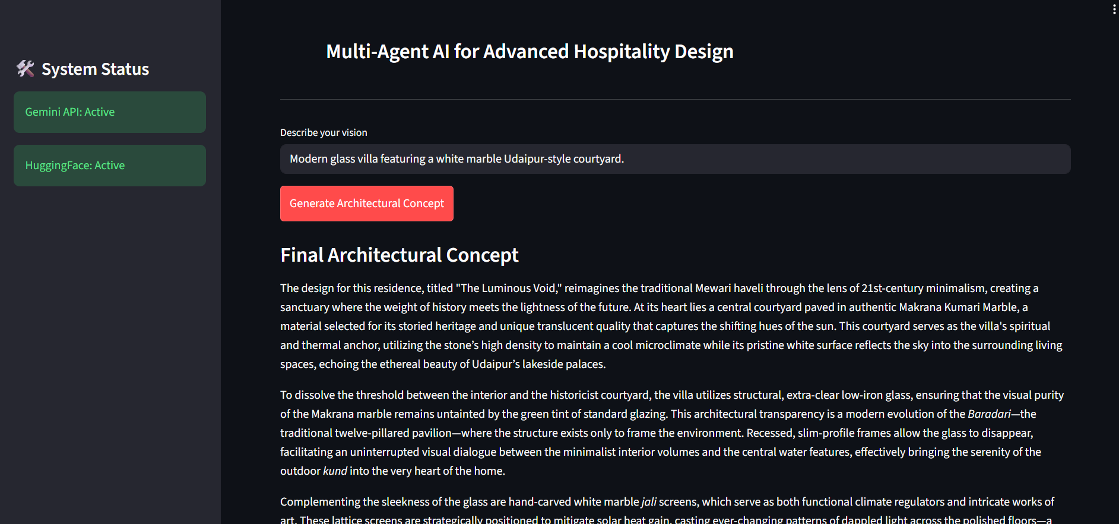

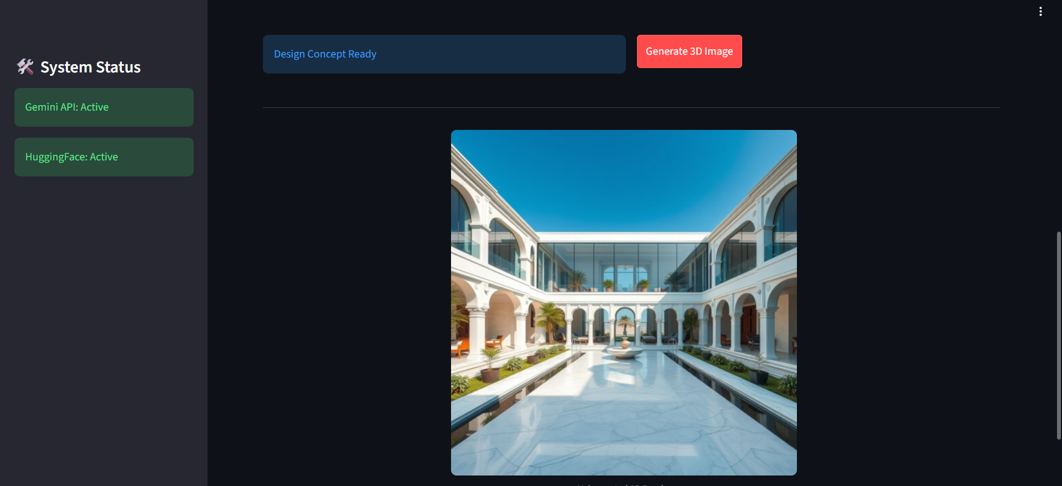
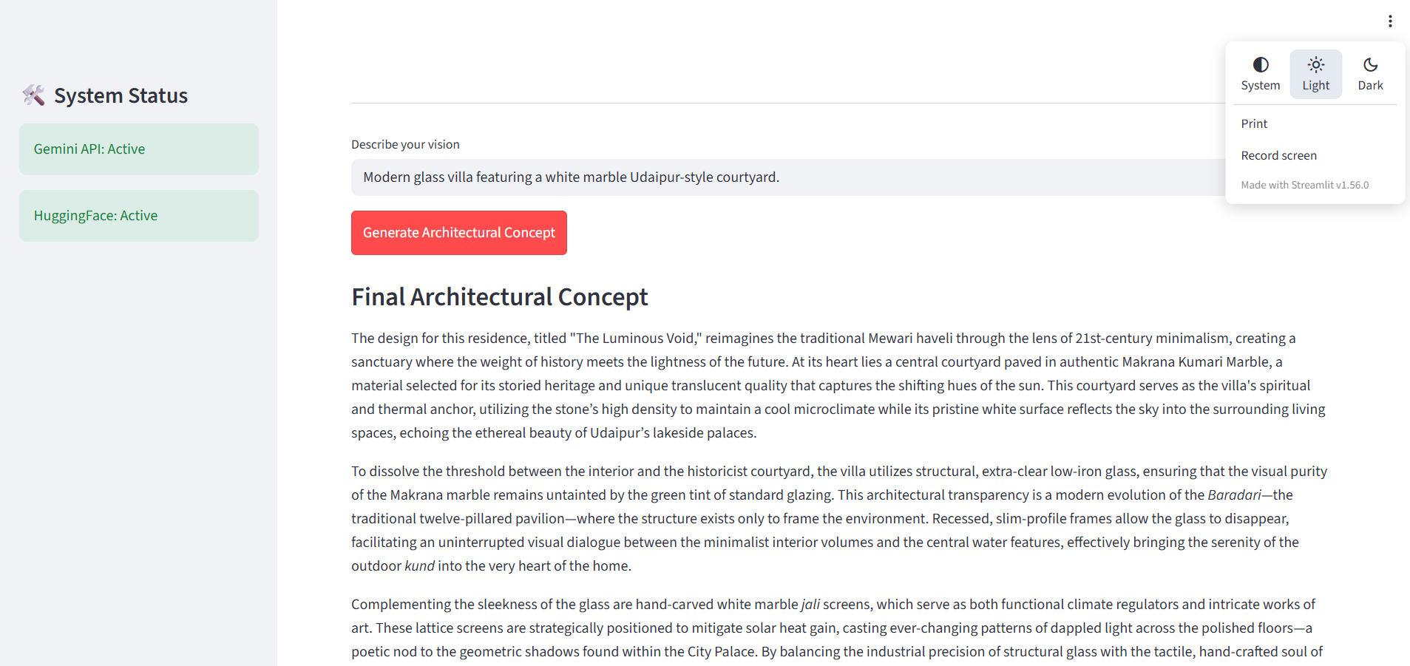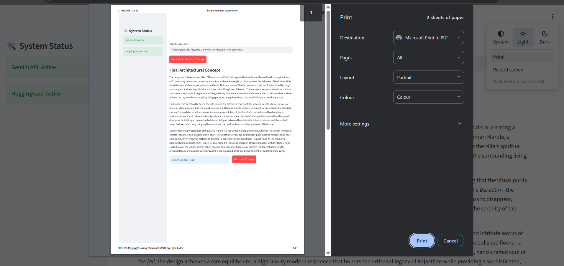
5.2 CI/CD Pipeline and Automation Results
The Integrated Project CI served as the primary quality gate for the development lifecycle.
- Syntax Reliability: The automated use of py_compile ensured that every push to the repository was free of syntax and indentation errors.
- Deployment Stability: The pipeline confirmed that all dependencies in requirements.txt were resolvable, reducing local-to-production deployment issues to zero.
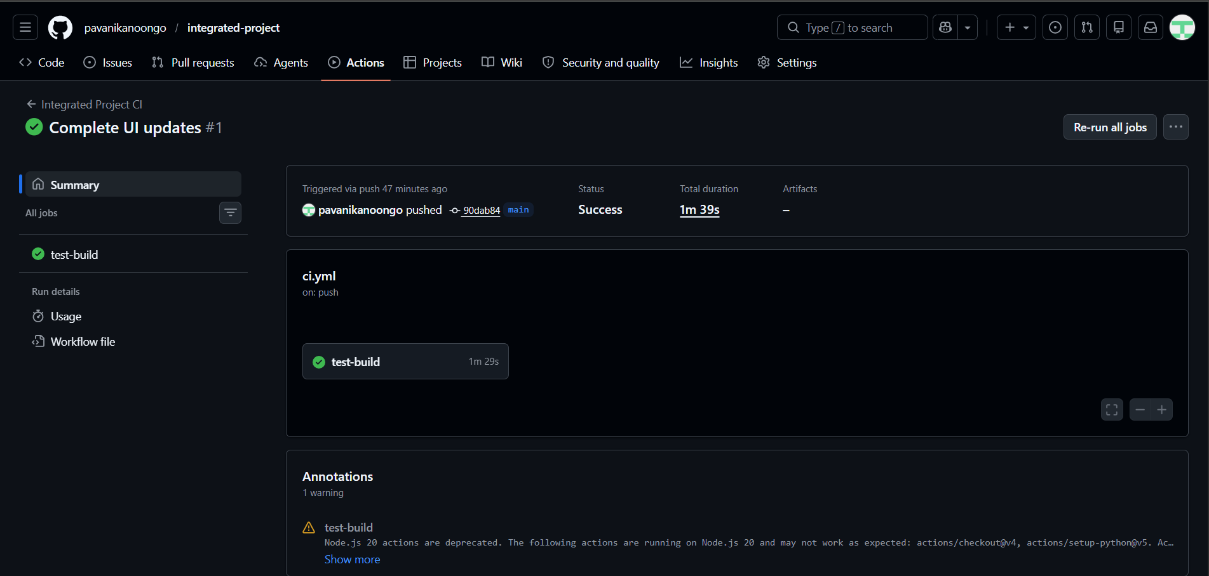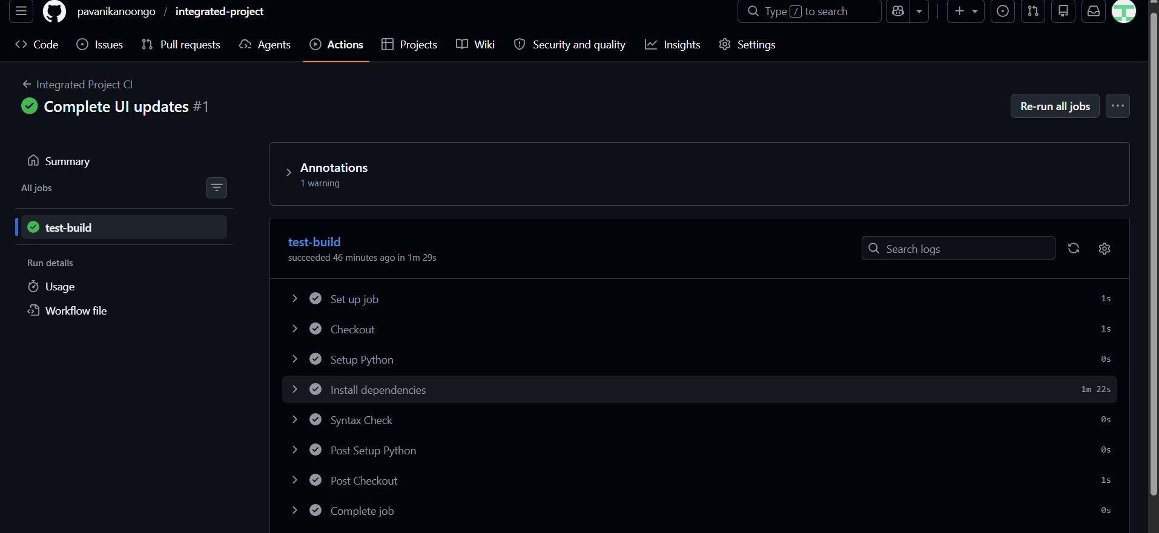
5.3 Docker Containerization Outcomes
The project successfully moved beyond "local-only" execution through Docker implementation.
- Environment Parity: The application was tested across different environments and performed identically, proving the effectiveness of the containerized setup.
- Resource Efficiency: By including build-essential in the Dockerfile, we successfully resolved complex C++ dependencies required by the vector database without manual intervention.
5.4 Discussion of Findings
The results indicate that an integrated approach—combining GenAI for creative tasks and DevOps for operational stability—is essential for professional-grade software. The transition from manual testing to automated CI/CD allowed for faster UI iterations without risking the core logic of the multi-agent system.

Chapter 6: Summary and Conclusions
6.1 Summary of the Work
This project successfully developed an integrated software solution titled Multi-Agent AI for Advanced Hospitality Design. The core of the investigation involved orchestrating a specialized team of AI agents using CrewAI, LangChain, and Pydantic to automate architectural research and visualization. A significant portion of the work was dedicated to establishing a professional DevOps lifecycle, which included authoring a Dockerfile for environment portability and configuring a GitHub Actions pipeline for Continuous Integration. This integrated approach ensured that the high-fidelity 3D renders generated by the GenAI models were backed by a stable, containerized, and version-controlled infrastructure.
6.2 Conclusions
The following conclusions are derived from the project implementation and the results of the investigation:
- Orchestration vs. Single-Prompting: The multi-agent architecture proved superior to standard single-prompting by allowing for specialized roles—such as the Architectural Researcher and Visualizer—resulting in more contextually accurate design concepts.
- DevOps as a Quality Gate: The implementation of the Integrated Project CI pipeline effectively eliminated syntax and indentation errors through automated py_compile checks, ensuring that only verified code reached the main branch.
- Environment Parity: Docker containerization successfully resolved complex dependency conflicts, particularly for ChromaDB, providing a consistent runtime environment across different development platforms.
- UI Professionalism: Iterative refinements to the Streamlit interface, including the removal of manual token inputs and the optimization of visual layout, resulted in a more professional and user-friendly design dashboard.

Chapter 7: Future Scope
The project serves as a foundation for further advancements in the intersection of AI and architectural operations. Future enhancements include:
- Continuous Deployment (CD): Extending the current CI pipeline to automatically deploy validated Docker containers to cloud registries or hosting services.
- Enhanced RAG Datasets: Expanding the ChromaDB vector store within the hospitality_data directory to include real-world building codes and sustainability standards.
- Local LLM Integration: Incorporating local Large Language Models to enhance data privacy and reduce latency associated with external API calls.
- Real-Time Collaboration: Developing features that allow multiple users to interact with the agentic workflow simultaneously for collaborative design sessions.

Bibliography
- CrewAI Documentation, "Orchestrating Role-Playing Collaboration of AI Agents," https://docs.crewai.com
- GitHub Actions Guide, "Automating your workflow with GitHub Actions," https://docs.github.com/en/actions.
- Streamlit Documentation, "Building Interactive Data Applications in Python," https://docs.streamlit.io.
- ChromaDB Documentation, "The AI-native open-source embedding database," https://docs.trychroma.com.
- Hugging Face API Reference, "Inference API for Generative AI Models," https://huggingface.co/docs/api-inference.

